**Worksheet: Discovering Vectors Between Points**

**Objective:**

To explore and understand how to determine the vector between two points using graphical and algebraic methods.

## **Instructions:**

1. Open the Desmos Geometry Calculator at [Desmos | Geometry](https://www.desmos.com/geometry).
2. Complete the following tasks using both graphical representation on Desmos and manual calculations. Write your solutions in the space provided.

## **Section A: Graphical Exploration**

1. Plot the points A(2,3) and B(4,5) on Desmos.
   * Draw the vector AB⃗.
   * Describe the movement from A to B (e.g., right 3 units, up 4 units).  
     Right 2 units, up 2 units.

**Observation:** What is the vector AB⃗ in Cartesian form? AB⃗ = (2, 2) = 2i + 2j

1. Plot the points C(−2,4) and D(1,−3).
   * Draw the vector CD⃗.
   * What is the direction and magnitude of the vector?  
     Direction = -66.8 degrees, Magnitude = 7.616 units

**Observation:** What is the vector CD⃗ in Cartesian form? CD⃗ = (3, -7) = 3i - 7j

**Section B: Formulaic Solution**The formula for finding the vector PQ⃗\ ​ between two points P(x1,y1) and Q(x2,y2) is:

|  |
| --- |
| PQ⃗ = (xQ−xP, yQ−yP) |

1. Calculate AB⃗ from A(2,3) to B(4,5).

AB⃗ = (x2−x1,y2−y1) = (4−2, 5−3) = (2, 2), Written in cartesian form 2i + 2j

1. Calculate CD⃗ from C(−2,4) to D(1,−3).

CD⃗ = (x2−x1, y2−y1) = (1−(−2), −3−4) = ( __, __), Written in cartesian form __ i + __ j

**Section C: Linking Desmos and Formulaic Solutions**Compare your graphical vectors on Desmos with your formulaic results.

* Do the Cartesian coordinates match the movement observed on the graph?
* Discuss how the formula simplifies finding vectors without plotting.

**Section D: Application Challenge**

1. A robot moves from point P(3,−1) to point Q(−2,4). Determine the vector of its movement.
2. A wind blows a boat from R(0,0) to S(6,8). Determine the vector and its magnitude (use $d= \sqrt{x^{2}+y^{2}}$)
3. Use Desmos to visualize these movements. Screenshot your graph and attach it.

**Submission Checklist:**

- Completed all tasks in Sections A, B, C, and D.

- Reflected on the connection between Desmos and formulaic solutions.

- Attached Desmos screenshots where required.

**Desmos samples (answers to geometric views):**

**[Example 1 answer](https://www.desmos.com/geometry/v49skiecm5)**

**[Example 2 answer](https://www.desmos.com/geometry/tzva7inz6l)**

[**Section D Desmos answer for Q1**](https://www.desmos.com/geometry/gktdrsdyu6)

**Link Jacplus approach – for a deeper dive, (considering equivalence)**

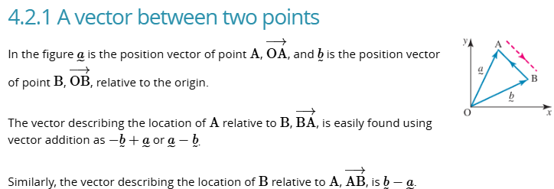

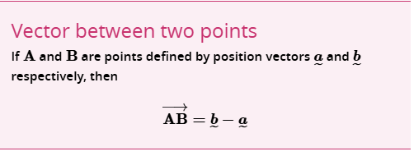

The text book looks slightly different to our formula, but it is the same as you can simply put the two points into cartesian form and apply this equation. See Worked example 1.

I will use this formula for the two problems we did above:

1. **Calculate AB⃗ from A(2,3) to B(4,5).**

|  |  |
| --- | --- |
| Write A and B in cartesian form | ~A = 2i + 3j B = 4i + 5j |
| AB = b – a, so subtract vector a from b | AB = b – a  = 4i + 5j – (2i – 3j) |
| Solve this out…  ANSWER will be in Cartesian form | = 4 – 2 i + 5 - 3 j  = 2i + 2j |

We are using vectors OA and OB (so instead of thinking of two points A and B, you consider A from the origin (as OA) and you consider B from the origin (as OB)

|  |  |
| --- | --- |
|  |  |
| From Jacplus notes | From this example |

To calculate vector from point A to point B, you can use EQUIVALENCE whereby you start at Point A, and to get to B, you can trace back to the origin, backwards from point A, then go to point B. That is a ‘long’ way to go from A to B, but it is EQUIVALENT, and we can use this method, because the address of the origin is easy for us, i.e. (0,0).

Hence we can use the vector position of A from the origin as OA, and similarly the vector position of point B is OB.

|  |  |
| --- | --- |
| Write A and B in cartesian form  These give you the points A and B as vectors from the origin of the plane | ~OA = 2i + 3j OB = 4i + 5j |
| AB = -OB + OA  Which is re-written as:  AB = OA – OB | AB = - OA + OB  = OB - OA  = 4i + 5j – (2i – 3j) |
| becomes exactly as above….  ANSWER will also be in Cartesian form | = 4 – 2 i + 5 - 3 j  = 2i + 2j |

1. **Calculate CD⃗ from C(−2,4) to D(1,−3).**

Use techniques as above.